REQUEST FOR
ARCHITECTURAL & ENGINEERING
PLANNING SERVICES

Southwest Quadrant Redevelopment Plan

February 2013

Project No. 12L2Y

TABLE OF CONTENTS PAGE
Project Background and Purpose 1
Project Description and Scope 1
Project Deliverables 4
Consultant Qualifications 4
Letter of Interest Submittal Requirements 5
Contacts 5
Project Schedule 5
Additional Documents 5
Attachment A 6

Background and Purpose

UW-Milwaukee offers a uniquely relevant learning experience, educating more Wisconsin residents than any other university and recruiting a growing population of international students and faculty. As the most diverse institution in the University of Wisconsin System, UW-Milwaukee is a learning destination for 30,000 students from 50 states and 80 countries. A world-class faculty offers a broad curriculum across 14 schools and colleges, inspired by academia throughout the ages and 21st-century career opportunities and scientific discovery. There are 180 degree programs and counting.
UW-Milwaukee’s status as a Research University means scholars from freshman year through post-doctoral fellowship have myriad opportunities to test their ideas and enhance their resumes through research, internship and international learning opportunities.
With roots going back to 1885, the University of Wisconsin-Milwaukee name and identity have changed over the years. A continuous commitment to rigorous, relevant and real-world learning and professional development for all students has resulted in over 140,000 alumni worldwide.
A campus master planning process was completed in 2010 to guide the growing space needs of the campus in accommodating academic, research and student life in a supportive physical environment. The Master Plan identifies 550,000 GSF of new space for educational and research needs over the next ten years. It defines the needs and development of the Southwest Quadrant as follows:
The southwest quadrant of the Kenwood campus includes about 15% of the campus footprint. It will be home to a series of new buildings as planned by the 2010 Master Plan. The existing Engineering Math and Science (EMS Building), Chemistry and Lapham buildings and several new interdisciplinary research centers (IRC) will meet many of the projected growth needs in the College of Engineering and Applied Science and within the Natural Sciences of the College of Letters & Sciences. The existing Physics building will be demolished with replacement of space provided in new and existing buildings in this quadrant. The Children’s Center within the Kunkle building will be relocated to another site on the Kenwood campus. Based on future projections and the desire to locate research near private partners, some research space will locate at the expanded School of Freshwater Sciences or future Innovation Park IRC.
Phased implementation of the master plan for the southwest quadrant will support the education programs and research growth, while meeting the immediate and long term campus needs for space.
The Kenwood Interdisciplinary Research Center, 143,500 gsf, is currently under construction. The Children’s Learning Center will be relocated to the Northwest Quadrant early 2014.
The UW-Milwaukee Campus Master Plan (2010) can be found at the following link: http://www4.uwm.edu/master_plan/index.cfm .

Project Description and Scope

The Southwest Quadrant (SWQ) Redevelopment Plan will provide the evaluation of facility conditions for those buildings noted, assess the space needs for the user groups identified, and comprehensively evaluate and assess options for adaptive reuse, renovation, new construction and demolition to optimize the redevelopment of the SWQ. This plan will:
- Identify and evaluate alternative scenarios for redevelopment;
- Determine a preferred redevelopment scenario with a phased implementation plan that addresses sequence, timeline, and funding strategies;
- Prepare (for the discrete projects that would comprise that preferred scenario) one of two types of documents as follows:
  - Feasibility assessments developing select elements of the future projects ‘Program Statement’ as needed for the planning and justification of the project that could possibly be undertaken during 2015 – 2021 biennia. This document would further aid the campus in addressing program, scope, budget and schedule with a conceptual test fit of adaptively reused spaces and blocking and stacking for additions. The elements to be incorporated into the ‘Feasibility Assessment’ shall be determined by the project team as the project is conceptualized under redevelopment scenario.
  - Projects making up the balance of the preferred redevelopment scenario and likely to occur beyond 2021, prepare characterizations of the approximate locations, programs, costs, and timeframes.
The Southwest Quadrant Redevelopment Plan will assess existing conditions and functionality of the buildings of the Southwest quadrant noted below and portions of Garland Pearse Hall, using an approved System Facility Condition Assessment (FCA) process and format. These FCA will be evaluated against state of the art teaching/learning and research facilities and projected space needs.
Crafting of the Redevelopment Plan will include evaluating the reconfiguration and reassignment of department and program space for faculty and staff, new instructional spaces, conference and meeting spaces and research space. It will address connectivity of existing and new buildings, balancing open space with existing and proposed buildings, maintaining/enhancing existing athletics fields, upgrading utility infrastructure and the development of a new UW-Milwaukee identity for the SWQ-entry to campus from the west.
Core User Groups that will be engaged during the study:
- College of Letters & Sciences – Mathematical Sciences, Physics, Chemistry and Biochemistry
- College of Engineering and Applied Sciences – Civil/Mechanics, Computer, Electrical, Industrial & Manufacturing, Materials, and Mechanical
- Multidisciplinary Research Institute - Biological Sciences, Geosciences, Public Health, Nursing, College of Health Sciences, Psychology
- Parking and Transit
In addition, there will necessary coordination with the Union to evaluate decentralization of some services/operations, currently housed in the Union.

Table 1: UW-Milwaukee Building Designations for the Southwest Quadrant
Building Name  *buildings requiring assessment | UWM Building Reference number (Designation) | Approximate Building Area (GSF) | Year Built
*Physics | (1984) | 108,329 | 1966
*EMS | (1985) | 247,872 | 1970
*Chemistry | (1974) | 149,596 | 1974
Lapham | (1982) | 284,585 | 1961,1992
Kenwood IRC | (1927A) | 150,000 | 2013-4
*EMS Parking Garage | (1985) | 69,564 | 1970
Cunningham | (1973) | 110,634 | 1973
Buildings not included in study:
Kunkle (slated for demolition)
Engelmann Hall
Architecture &Urban Planning
Total GSF |  | 1,120,580
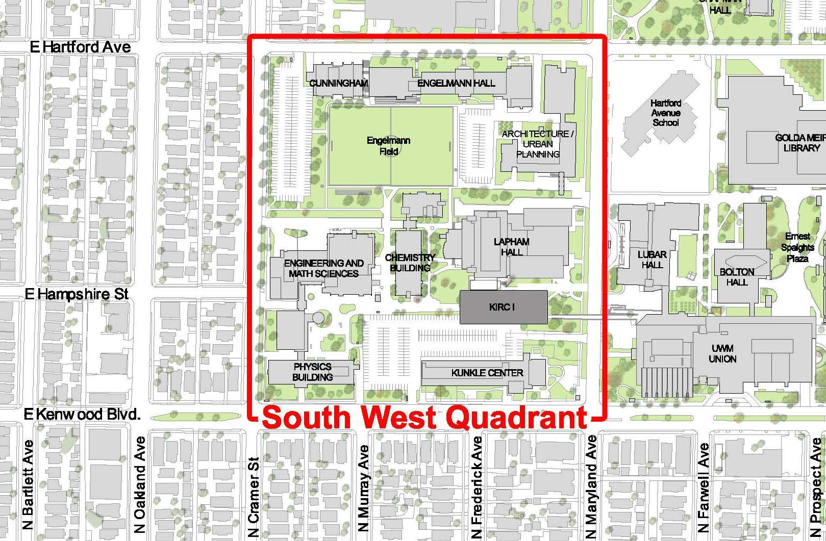

Current Projects Underway in the Southwest Quadrant
KIRC Phase I
Relocation of the Children’s Learning Center from Kunkle
Demolition of Kunkle
Currently Proposed Projects in the Southwest Quadrant:
Upgrade utility infrastructure to support new facilities
Remodel Chemistry Building
Additional new building(s)
Demolish Physics building

Refer to Attachment A –Planning Consultant Services Checklist for a specific list of services to be provided.

In general the consultant team is expected to prepare a plan that will be used to guide the physical development of the institution for the next twenty years. In addition to using the documentation that is referenced under additional documents, the consultant should be prepared to engage in an interactive information gathering and plan development process with a variety of stakeholders that include:
- Students
- Faculty
- Administrative Staff
- UW System Administration
- Division of Facilities Development
- Other State Agencies (DNR, WSHS)

UW-Milwaukee will develop an organizational structure to guide and interact with the consultant team during the redevelopment planning. At a minimum it is anticipated that there will be a core team to provide direction and facilitate planning and focus groups to provide information and feedback.

Potential audiences and uses for the plan include:
- Institutional leadership
- Institutional community and prospective students, faculty and staff
- Board of Regents and UW System Administration
- State Building Commission and Division of Facilities Development
- City of Milwaukee and Milwaukee County
- Neighbors (if this is different from institutional community)
- Alumni, Potential donors, Board of Visitors

Project Deliverables

Deliverables will include the following for both the Southwest Quadrant Redevelopment Plan and Project Feasibility Assessments:
  - Draft table of contents and document format
  - Draft preliminary document
  - Preliminary document
  - Draft final document
  - Final document
- Ten (10) printed copies of an Executive Summary that summarizes findings, goals, principles, and key recommendations, and can be used as a stand-alone document.
- Ten (10) printed copies and PDF(s) of the final documents, either downloadable or on CDs.
- One PowerPoint file of a summary presentation of the SWQ Redevelopment Plan process and resulting recommendations.

Deliverable requirements:
- The final document should be appropriate for use in the public domain.
- The final document should be clear, concise and forward-focused.
- The final document should have a professional published appearance and format. Graphics should be readable in either color or black and white printed formats. The document should be letter size, either portrait or landscape, but may contain tabloid size fold-outs.
- All final site plans shall be delivered in AutoCAD 11 format or higher.

Consultant Qualifications

Well qualified firms will have a team comprised of a capable project manager and specialists as necessary to meet the project goals; expertise and experience in providing campus planning services for large, public universities of a size and population similar to UW-Milwaukee; considerable experience in design of new higher education facilities, and renovation/adaptive reuse of existing higher education facilities with scopes and sizes similar to the projects that will result from this study.
Well-qualified teams will also have the following specific design experience:
- Considerable knowledge of space needs assessment, programming and design of state of the art higher education teaching and research facilities for higher education
- Considerable knowledge of higher education building, infrastructure and land use planning
- Building and infrastructure assessment
- A thorough knowledge of State of Wisconsin’s building and energy standards, Building Code and City of Milwaukee Zoning requirements
- Experience in providing cost-estimating, scheduling for new and renovated buildings
- Ability to conduct focus groups with all stakeholders for the process including students, staff, faculty, and administration

Letter-of-Interest Submittal Requirements

The letter-of-interest submitted by the consultant team should concisely include the following information:
- General qualifications of your firm and your consultant team including a brief history, your principal client base, the firm’s size, comparable project experience and the services you offer.
- Information on three or four of your recently completed similar redevelopment projects. Include a project description highlighting the primary issues that were addressed such as programming or design challenges, building conditions, code. requirements, project costs, etc. Provide owner contacts on all representative projects for reference.
- A list of key personnel and sub-consultants assignments and a brief description of similar, substantially completed project experience for each key staffer.
- A list of space planning project experience that includes programming, planning, and design of single and multi-discipline higher education promoting collaboration such as instructional and research based science laboratories; instructional technology and general assignment classrooms.

Contacts

UW-Milwaukee | Karen Wolfert | Facilities Architect | (414) 229-2499 | wolfertk@uwm.edu
UW-System Admin | Jeff Kosloske | Senior Architect | (608) 263-4417 | jkosloske@uwsa.edu

Project Schedule

Below is the general project schedule that will be finalized upon consultant selection and during the final scoping process of the planning project.

Consultant Selection Process | March 2013
Initiate Project | April 2013
Complete space needs assessment, programming and building analyses | April – July 2013
Develop concepts | July – August 2013
Redevelopment Plan draft complete | September 2013
Complete Feasibility Assessments | October–March 2014
Complete project and deliverables | May 2014

Additional Documents provided to the selected AE team
- 2010 Campus Master Plan. http://www4.uwm.edu/master_plan/index.cfm
- Kenwood Campus Map Location: http://www4.uwm.edu/map/map_color.pdf
- Existing site survey in AutoCAD including utilities and surface features.
- Simplified floor plans in AutoCAD of all Buildings
- Space utilization/room data in Access or Excel spreadsheet formats
- Record documents on file for the original construction for most buildings as well as subsequent renovations

ATTACHMENT A - PLANNING SERVICES CHECKLIST
Provide the following services noted with
PART 1 - Standard Planning Services
1. | Space Needs Analysis and Recommendations based on scheduling/ utililization data, program delivery, enrollment trends, and appropriate benchmarks
 | For the following Core Users:
 | a. | College of Letters & Sciences
 | b. | College of Engineering and Applied Sciences
 | c. | Research Themes/Areas – Above users plus Zilber School of Public Health, College of Nursing, College of Health Sciences, School of Freshwater Sciences
 | d. | Parking and Transit
 | e. | UITS (University Information and Technology Services)
 | f. | Coordinate with concurrent design of the Union Gateway /Conference Center
2. | Facility Condition Assessments
 | Produce a Facility Condition Assessment document verifying information provided by institution for the following buildings:
 | a. | Physics
 | b. | EMS
 | c. | Chemistry
 | d. | EMS Parking
 | e. | portions of Garland Pearse Hall
3. | Review of existing plans that include:
 | a. | Campus Master Plan, Strategic Plan, Academic Plan
 | b. | Existing building, site and utility plans
4. | Land and building use analysis and recommendations:
 | a. | Zoning review
 | b. | Building code review
 | c. | Building functionality for identified programmatic use
5. | Circulation and transportation analysis and recommendations that include:
 | a. | Roads, vehicular traffic, and parking
 | b. | Bicycle paths,traffic and storage
 | c. | Pedestrian paths and traffic
 | d. | Deliveries
6. | Utilities condition, capacity analysis and recommendations for the following:
 | a. | Central steam, chilled water, electrical, telecommunications, water, sewer and stormwater
7. | Benchmarking
 | a. | Provide national benchmark data on recent university teaching/learning and research facilities. Show a wide variety of layouts for classrooms and labs. Include photographs and floor plans of benchmark facilities.
8. | Overall Redevelopment Plan and Potential Projects: Develop a minimum of three alternative scenarios and a Preferred Scenario and Implementation Plan that includes:
 | a. | Site Location
 | b. | ASF/GSF and number of stories
 | c. | Project costs (in current dollars in DFD/UW System format)
 | d. | Phasing and interim use

